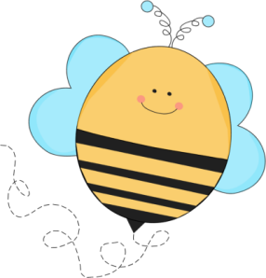
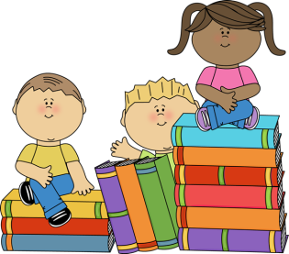

Battle of the Books
Frequently Asked Questions

- Who can participate?
BOB is open to all motivated readers in 4th and 5th grade

- When and where are the meetings?
Every Tuesday from 4:00-4:45 starting December 17, 2019 in room 2311.

- Is there a parent meeting?
Yes! December 5th from 5:00-5:30 in room 2311

- Who are the coaches?
Mrs. Estrela and Mrs. Beard

- What are the students supposed to read?
- Students will be assigned books to read. Assigned lists will be given out at the first meeting in December. There are 15 books on the list, but students are only required to read their assigned 10 books.

- How are teams formed?
The coaches will be forming the teams.

- Does my child have to read all 15 books on the list?
No, your child must read the 10 books that are assigned to him/her

- Can my child read all of the books?
Of course!

- Where can I find the books?
- CES library
- Public library
- Amazon
- Barnes and Noble

- Can we share books?
- Yes, you are encouraged to share books with your team so you don’t have to buy them all.

- Do we travel to other schools?
- No, this is a competition at Cary Elementary only

- How do I prepare?
- You can make up questions to ask teammates
- You can complete graphic organizers to help you remember details
- You can record details in a journal or on sticky notes as you read
- You can reread the books you are assigned

- What are the questions like?
- All questions begin with the phrase, “In which book…”
- The answer is the title and the author

- Do my parents come to the club meetings?
- They do not need to come to practices, but we will need a lot of parent volunteers to help on the day of the battle.

- What if I can’t finish all 10 books assigned to me?
- It is important for you to read for your team. The more each member reads, the better your team will do during the competition. If you find that you are having trouble getting the reading finished or finding the books, please ask for help.

